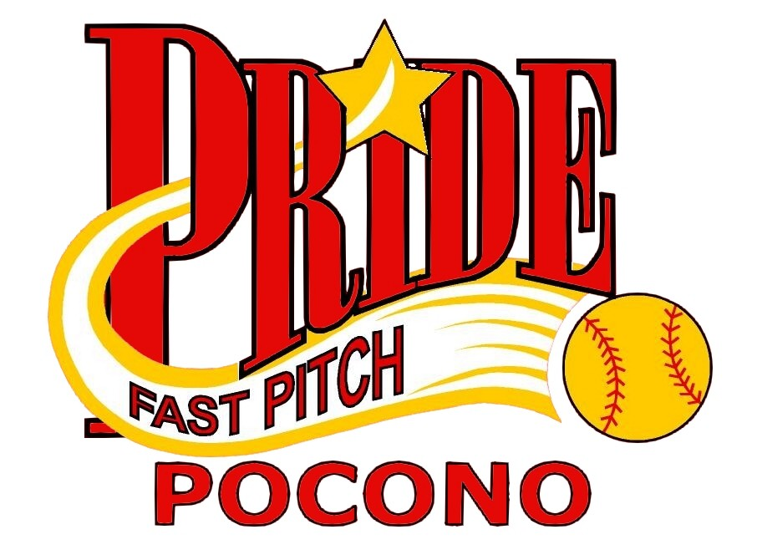
Sponsorship Form

$1 - $99: Walk Sponsor
Honorable Mention on website
$100 - $199: Single Sponsor
Name, phone and address listed on our website
$200 - $499: Double Sponsor
Small logo, name, address and phone on our website and name listed on our team banner
$500 - $999: Triple Sponsor
Large logo, link to your business, name, address and phone on our website and name listed on our team banner
$1000 & Over: Home Run Sponsor
Large logo, link to your business, name, address, phone and write up on our on our website, name listed on our team banner and team plaque at the end of the season

Total Donation:

Business Name:

Address:

City, State, Zip:

Phone Number:

Website Address:

Date:

$

Please attach a business card or logo picture for donations of $201 & over for logo on our website. For donations over $1000 please attach a write up of your business as you would like it to appear on our website. Make checks payable to “Pocono Pride”.

Player securing this sponsor:

Pocono Pride Fast Pitch Softball • P.O. Box 1136 Pocono Summit PA 18346 • www.poconopride.com

